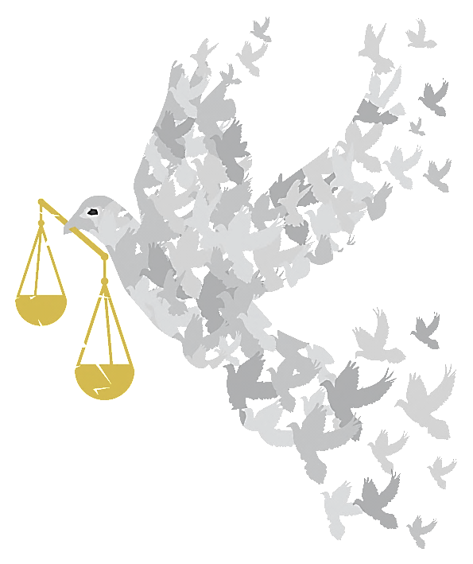

PLEDGES
of HOPE to INSPIRE ACTION

PLEDGES of HOPE to INSPIRE ACTION

Solemn binding promises to do, give, or refrain from doing something
How can I use this resource?
You can use these pledges to encourage people to think about what inspires them and how we can build a culture of hope and confidence that by taking action, especially action together, we can challenge injustice and build a fairer more peaceful world, fit for our children to live in.
Possible activities:
- You could separate the pledges from the reasons, and ask people to match them back together. To add a competitive element, people could work in teams, with the first team to complete the task correctly winning a small prize.
- Put all of the pledges into a ‘Pledge Box’ and take it in turns to pick one out. Discuss how the pledge could be implemented.
- Use the dove template (on page 7) to make cards with pledges on one side and the reasons on the other or offer blank ones for people to write their own. Use Velcro or blutac to attach them to a board or window making the shape of the dove logo on the cover to symbolise people coming together as a movement.
- Display your pledges by writing them on strips of brightly coloured paper and linking them together in a ‘Chain of hope’ that could be displayed in your office, school, place of worship or community centre.
- Or put them (on cards or doves) on a table for people to choose one that they will take home and try to implement.
- Set up a craft activity to make pledge badges to wear (you could use a smaller version of the dove as template).
- Put your pledge into action and make sure you regularly check how well you are doing. Encourage others to join you, and keep each other motivated.

I pledge to…  Switch to an ethical bank | Why?  Because it is good to take control and know that your savings invest in positive improvements instead of the arms trade or fossil fuel extraction or hold developing world debt.  To find one that’s right for you look at http://moveyourmoney.org.uk/
I pledge to…  Talk to someone from a different faith or culture to myself | Why?  Because the world’s major religions all say something about equality and all advocate peace. But people’s perception is increasingly that religion is the cause of violence. Greater understanding decreases suspicion and increases friendship, unity and solidarity.
I pledge to…  Talk to my neighbours | Why?  Because it develops relationships, forges a sense of community and makes us feel part of where we live. We can look out for each other, so everyone worries less and has greater personal peace.
I pledge to...  Pray for peace at the personal, local and global levels | Why?  Because praying for peace can be a powerful and positive experience, and all faiths teach the importance of peace.
I pledge to...  Try to do only to others what I would have done to myself | Why?  Because if everyone can follow this example we would all be treated with love, kindness and respect, and this would bring greater fairness, peace and harmony to the world.
I pledge to…  Buy Fair Trade products and keep on buying them | Why?  Because buying fair trade means empowering producers not exploiting them. They get a fair deal which allows them to feed and educate their families, access healthcare and develop their communities, in harmony with their environment and each other.
I pledge to…  Buy organic goods whenever possible | Why?  Because other crops are sprayed with highly pollutant insecticides which not only damage the environment but the communities around the farming areas. Healthy soils, bees and food offer hope for economic and environmental sustainability for the future.
I pledge to…  Take action against injustice | Why?  Because whether it is an apparent miscarriage of justice which has been reported in the media or a local event in your school, community or workplace, writing a letter, signing petitions and speaking up are powerful tools
I pledge to…  Set up a standing order to an agency that works alongside the world’s poorest people | Why?  Because when charities have a regular income rather than occasional gifts, they can plan better and use the money in more efficient ways to implement and sustain peace and justice.
I pledge to…  Count to ten before speaking, if I feel like I am losing my temper | Why?  Because talking calmly solves a lot more problems than shouting or lashing out.
I pledge to…  Find out about non-violent protest | Why?  Because with patience, words and peaceful action you can bring about real change for the better.
I pledge to…  Praise good behaviour | Why?  Because praise inspires people and encourages more of the same.
I pledge to…  Read and share good news stories | Why?  Because they will put the bad news into perspective and inspire people to believe that a better world is possible.
I pledge to…  Support an education charity | Why?  Because education is a key to equality which reduces conflict and leads to hope and peace.
I pledge to…  Find ways to practically support local refugees and asylum seekers. | Why?  Because it is the humane way to treat victims of injustice, violence and war and can bring hope to future generations.
I pledge to…  Smile more – especially to people I don’t know | Why?  Because a smile inspires people to feel good about themselves and respond positively.
I pledge to…  Join on-line campaigning groups like 38 Degrees and Avaaz | Why?  Because I can join my voice with millions of others worldwide to tell politicians and big business what we would like them to do to make the world just and sustainable.
I pledge to…  Tell my local MP what I would like her/him to do to ensure that my community thrives sustainably... | Why?  Because if enough people speak up, change will really happen.
I pledge to…  Find of examples of people acting together successfully to challenge injustice- and tell others | Why?  Because stories of success inspire hope and encourage others to take action.
I pledge to…  Switch to a green energy supplier | Why?  Because I want to distance myself from the fossil fuel suppliers that drive climate change and instead be part of the movement that is signalling a demand for sustainable energy production to encourage investment in it and phase out fossil fuel production. See http://www.greenelectricity.org/
I pledge to…  Support community energy projects | Why?  Because such projects are local and more democratically controlled which shifts the balance of power away from the Big Six energy companies.
I pledge to…  Buy wood and wood based products with the FSC logo on it | Why?  Because many forests are being illegally logged, displacing indigenous peoples who use the forests sustainably, causing conflict and poverty. This FSC logo verifies that the wood is from a sustainable source.
I pledge to…  Join the local branch of a group campaigning for global justice | Why?  Because sharing information with others and taking action together is mutually supportive and much more fun and more effective than doing it on your own!

