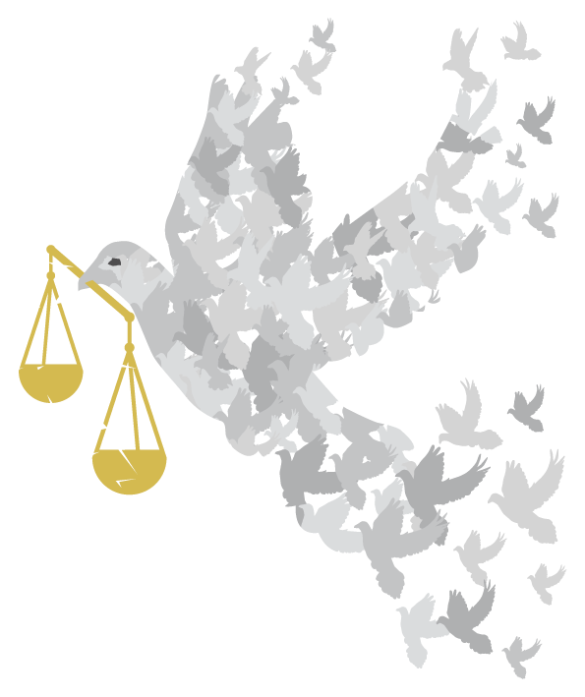

How could you use these quotations?
- To stimulate thinking - you could select individual quotations, enlarge them and print them off – then put them in eye-catching positions around your event:
  - on tables if you are having a meal;
  - on seats for a presentation;
  - on the wall, if people are circulating;
  - include them in displays;
  - include appropriate ones in an interfaith event or worship;
  - give one to everyone as they come into the event. (Follow up by inviting them to sign up to a pledge later in the event or as they leave – see Pledges)
  - Make the concise ones into bookmarks, laminate them, let people choose in return for a donation.
- As part of your publicity – choose pithy arresting ones to catch the interest!
- As part of a discussion activity - give one to everyone or, if people are sitting round a table, let people choose one they like. Invite them to share it with the others and initiate a discussion about what gives them hope for a more equal and peaceful world. You could use this together with the Pledges.
- As part of an interfaith event – invite people of various faiths to share their faiths’ teaching about an inclusive and peaceful society and bring quotations. You can offer these (pages 4-5) as a starting point or to add to the faiths represented at your event.
- Your ideas – we would love you to share your ideas about how to use quotations with other OWW organisers. Contact us and we’ll put them on the website.
The quotations
We found the following quotations from various sources, as indicated, - from websites, publications and reports. You will probably know lots more.
Please tell us about your favourites – with sources if possible and we’ll include some of them on the website or use them to update this list.

“The world is getting too small for both an Us and a Them. Us and Them have become co-dependent, intertwined, fixed to one another. We have no separate fates, but are bound together in one. And our fear of one another is the only thing capable of our undoing.”
Sam Killermann

If we are to live together in peace, we must come to know each other better
Lyndon Baines Johnson

We must learn to live together as brothers, or we are going to perish together as fools
Martin Luther King, Jr.

No culture can live, if it attempts to be exclusive.
Mohandas K. Gandhi

What the world needs most is openness: Open hearts, open doors, open eyes, open minds, open ears, open souls.
Robert Mulle

Peace cannot be kept by force. It can only be achieved by understanding
Albert Einstein

When everyone is included, everyone wins.
Jesse Jackson

We are less when we don't include everyone.
Stuart Milk

We all should know that diversity makes for a rich tapestry, and we must understand that all the threads of the tapestry are equal in value no matter what their colour.
Maya Angelou

If we are to teach real peace in this world, and if we are to carry on a real war against war, we shall have to begin with the children.
Mahatma Gandhi

Inclusion creates a relationship and cultural context where peace can flourish.
Judith Snow, Founder, International Association for Inclusive Citizenship

Faith related

Through understanding, peace is obtained.
Shri Guru Granth Sahib, Section 7 - Raag Gauree

[Prophet], call [people] to the way of your lord with wisdom and good teaching. Argue with them in the most courteous way.
Qur’an 16.125

The Prophet [peace be upon him] said “none of you truly believes until you love for others what you love for yourself”
[Bukhari]

“Whoever sees anything unjust, let him change it with his hands…”
[Hadith].

I'm a Muslim. I've been a Muslim for 20 years . . . You know me. I'm a boxer. I've been called the greatest. People recognize me for being a boxer and a man of truth. I wouldn't be here representing Islam if it were terrorist . . . I think all people should know the truth, come to recognize the truth. Islam is peace.
Muhammad Ali

But Islam has a still further service to render to the cause of humanity. It stands after all nearer to the real East than Europe does, and it possesses a magnificent tradition of inter-racial understanding and cooperation. No other society has such a record of success in uniting in an equality of status, of opportunity, and of endeavours so many and so various races of mankind...
H. A. R. Gibb Whither Islam; London, 932, p. 379

Let us pray that all living beings realise that they are all brothers and sisters, all nourished from the same life source.
Buddhist

I believe that to meet the challenges of our times, human beings will have to develop a greater sense of universal responsibility. Each of us must learn to work not just for oneself, one's own family, or nation, but for the benefit of all humankind. Universal responsibility is the key to human survival. It is the best foundation for world peace
Tenzin Gyatso, 14th Dalai Lama

If it is possible, so far as depends on you, live peaceably with all.
Romans 12.18

There is neither Jew nor Greek, there is neither slave nor free, there is no male and female, for you are all one in Christ Jesus.
Galatians 3:28 ESV

“… just as racism begins not as a screaming campaign of violence, but as a seed that gets watered by silence and by rumour, so does its antidote. …
If racism and violence grow from small seeds that are allowed to take root in the minds and hearts of our children, then it is equally true that these will be challenged not by wishful silence, but by the planting, watering and nurturing of seeds that grow hope, commitment and love.
It is not enough to dig up the bad seed; a good one has to be planted in its place”
Nick Baines, Bishop of Leeds
Thought for the Day June 30 2016

From Children’s literature

We all live with the objective of being happy: our lives are all different and yet the same.
Anne Frank, “The Diary of a Young Girl”

This planet is for everyone, borders are for no one. It’s all about freedom.
Benjamin Zephaniah, “Refugee Boy”

“What exactly was the difference?” he wondered to himself. “And who decided which people wore the striped pyjamas and which people wore the uniforms?”
John Boyne, “The Boy in the Striped Pyjamas”

What was it about the differences in others that scared some people so much?
Malorie Blackman, “Noughts and Crosses”

