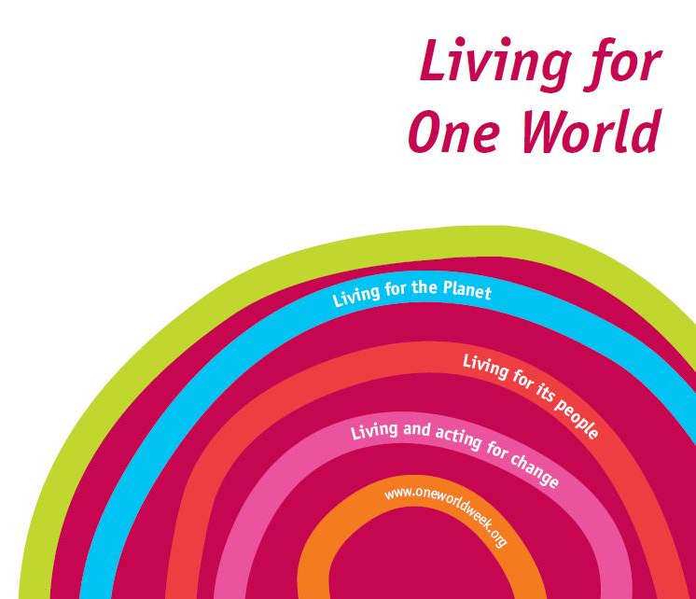 | Environment across faiths  Compiled by Sarah K. Kilou for One World Week

We have compiled a collection of teachings on the environment, across different faith traditions, for use at your OWW event.
Please note that this is not an exhaustive list, but a selection of excerpts taken from the scriptures of different faith traditions, on the natural environment.

How might I use this resource?
- You could select some of the excerpts below, to read at an inter-faith or multi-faith event.

- You could ask people from these respective faith traditions to say a few words of introduction before reading an excerpt.

- Another suggestion is to use the teachings as a basis for a discussion on faith and the environment across various world faiths.

- As a discussion warmer, you could cut and separate the teachings from the sources, and ask the group to match them together. To add a competitive element, the group that matches the teachings to the sources in the shortest amount of time (and correctly!), could win a small prize. This activity would lead nicely into a discussion on the similarities between faith traditions.

- An alternative to a matching activity could be a quiz; the quizmaster could read out each excerpt and the audience could work in pairs/groups to decide which faith group each teaching is from. A bonus point could be given for correctly identifying the source or any other additional information about each teaching.

Bahai Faith | Briefly, it is not only their fellow human beings that the beloved of God must treat with mercy and compassion, rather must they show forth the utmost loving-kindness to every living creature.... The feelings are one and the same, whether ye inflict pain on man or on beast. | Abdu'l-Bahá  Selections from the Writings of 'Abdu'l-Bahá, p. 158-159
Buddhism | The trees are like our mother and father, they feed us, nourish us and provide us with everything: the fruit, leaves, the branches, the trunk. They give us food and satisfy many of our needs. | Samdech Preah Maha  (highly revered Cambodian Monk)
Christianity | The earth is the Lord’s,  and everything in it. | The Bible, 1 Corinthians, 10:26
Daoism | If all things in the universe grow well, then a society is a community of affluence. If not, this kingdom is on the decline. | The China Daoist Association, Beijing
Hinduism | Every living creature is the son of the supreme Lord, and He does not tolerate even ants being killed. | Bhakitvedanta Swami Prabhupada, A.C Purport, Bhagavad Gita As It Is, 14:16
Islam | And the earth has He spread out for all living beings, with fruit thereon, and palm trees with sheathed clusters (of dates), and grain growing tall on its stalks, and sweet-smelling plants. | The Qur’an, 55:10-12
Jainism | Lord Mahavira preached about the environment in the book of ‘Acharanga Sutra’, which is accepted, as His direct words. The elements of nature were described as living beings and under the fundamental principle of AHIMSA there were to be protected in all ways – no waste, no overuse, no abuse, no polluting. | R.P Chandaria  Chairman of the Institute of Jainology, 15 August 2008
Judaism | And the Lord took man and put him in the Garden of Eden, to tend it and guard it. | The Bible, Genesis 2:15
Sikhism | Air is the Guru, Water is the Father, and Earth is the Great Mother of all. | The Second Guru, Guru Angad
  Zoroastrianism | Whoever teaches care for all these seven creations, does well and pleases the Bounteous Immortals;  Then his soul will never arrive at kinship with the Hostile Spirit.  When he has cared for the creations, the care of these Bounteous Immortals is for him,  And he must teach this to all mankind in the material world. | Shayast na Shayast,15:6

