

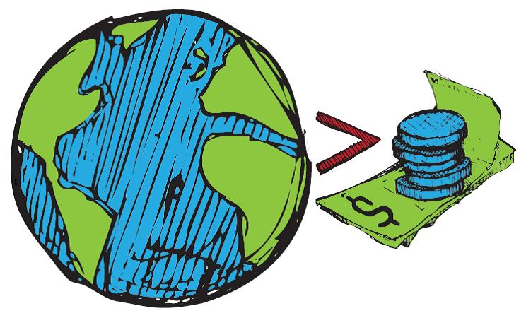

PLEDGES

to help us
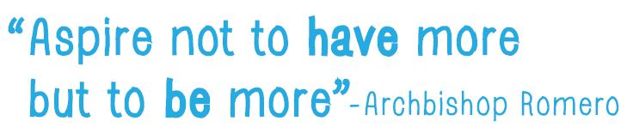

Introduction
How can I use this resource?
You can use these pledges to encourage people to think about what they can do to move beyond the current culture of consumerism towards being more engaged with our families, our neighbours, our local communities, our national affairs and our greater one world family. Humanity cannot afford to continue to consume the planet’s resources at the current rate. Wasteful use of resources is depleting and damaging ecosystems, increasing the rate of species extinction, and driving climate change, and leaving millions of people hungry. But reducing the time and money we spend shopping for the latest fashionable thing, releases us to engage in all sorts of activities that can make our lives more fun and more satisfying and contribute to making our local and global home a better place for everyone.
We need to be aware of our power to make a difference. By taking a stand to resist the commercial and social pressures upon us to buy more and more stuff which never satisfies us for long, we can instead focus on more rewarding activities that enable us to live in greater harmony with each other and with the environment. How we choose to “be” more will be personal to each of us. As we find ways to enhance our lives and the lives of those around us, without damaging the planet we shall also be making a positive contribution to future generations.
You could hold a More than Enough? event to start people thinking about how they might BE MORE and making a pledge, or you could use them as part of an event - perhaps to round it off with people making a commitment.
To begin an activity, you could review whether people at your event:
  - have had more than enough of being deﬁned by what we possess?
  - have had more than enough of consumer culture getting in the way of relationships with others in our communities and across the globe?
  - have had more than enough of seeing our planet irrevocably consumed?
consider we take more than enough ourselves? (cont. on p3)
Ask people if they want to add to this list ... then ...
You could divide into groups to discuss each of these – expand on them, explore why they matter and report back to the whole group.

Possible activities :
- You could separate the pledges from the reasons, and ask people to match them back together. To add a competitive element, people could work in teams, with the first team to complete the task correctly winning a small prize.
- Put all of the pledges into a ‘Pledge Box’ and take it in turns to pick one out. Discuss how the pledge could be implemented.
- Draw round a hand to make colourful cards to write your pledge on to symbolise a “hands- on” approach. Join them up to demonstrate how important doing things together is. You can make a decorative wall display or a banner. Or:
- Display your pledges by writing them on strips of brightly coloured paper and linking them together in a ‘Being More Pledge Chain’ that could be displayed in your office, school, place of worship or community centre.
- Or put them (on cards or handprints) on a table for people to choose one that they will take home and try to implement.
- Put your pledge into action and make sure you regularly check how well you are doing. Encourage others to join you, and keep each other motivated.

Send us your pledges with your name and locality and
we will publish them on our website to inspire others.

Pledges to enrich our world without wasting resources or damaging the planet
These pledges cater for a variety of situations, urban, and rural; different age ranges and family roles. There are even some pledges for Book clubs! Not all will be appropriate to everyone. You can select from these or write your own. Think about what is important to you, and how you can play apart in building a world fit for our children to live in.
I pledge to…  Repair or get things repaired where possible rather than replacing them with new. | Why?  Because I’ve had more than enough of the ‘throw away culture”. Making things last longer will reduce the amount of materials going through the system, so reduce the demand for new resources from our already over exploited planet.
I pledge to…  Eat local fruit and vegetables when in season (not forced in fossil fuel heated glass houses) and continue to eat Fairtrade imports too... | Why?  Because local produce uses less energy than goods imported by air. Eating seasonal vegetables helps us to appreciate the changing seasons and local specialities. Supporting your local farmers will reduce food transport costs and keep local traditions and identities alive. (buying Fairtrade will give small-holder farmers in developing countries a secure economic base from which to adapt to climate change and care for their families and their environment. Fairtrade imports often have a lower carbon footprint that local products grown in fossil fuel heated glass houses)
I pledge to…  Volunteer with my local volunteer bureau | Why?  Because I want to use some of my time to help make life better for people in the local community
I pledge to…  Ride a bike instead of taking the car when making short trips... | Why?  Because you can reduce your carbon footprint and get some healthy exercise, all at the same time!
I pledge to…  Find out about a religion I do not know much about... | Why?  Because we share our space with people of all the world’s major religions. They all advocate environmental sustainability and offer valuable insights into what is it means to be fully human...
I pledge to…  Keep buying Fairtrade products... | Why?  Because buying fairly traded products means a better deal for the producers, which allows them to provide for their families, develop their communities and also to care for their land and adapt to climate change. It sets an example of how trade should treat producers justly
I pledge to…  Write/print on both sides of every piece of paper... | Why?  Because it produces less waste so it is kinder to the environment. Deforestation ruins indigenous homesteads and animals’ habitats contributing to species extinction, creating social and environmental instability and threatens to leave future generations without species we enjoy today.
I pledge to…  Start a direct debit to an agency that works alongside the world’s poorest people... | Why?  Because when charities have a regular income rather than occasional gifts, they can plan better and use the money in more efficient ways to work towards economic and environmental justice through various initiatives.
I pledge to…  Eat less meat... | Why?  Because if we ate less meat we could afford free-range meat which enables livestock to live in a more natural environment; - and would reduce greenhouse gas emissions and safeguard our health too. (Animals living indoors close together need lots of antibiotics to stay healthy ; that encourages antibiotic resistance which can be passed on in their meat, threatening the human health)
I pledge to…  Try out a new recipe using local seasonal products every month | Why?  Because my family will enjoy it, local farmers will benefit and we‘ll all appreciate the links between production and the food we eat.
I pledge to...  Support a local food bank | Why?  Because people are hungry here too - they have insufficient income to feed themselves and their families properly, as a result of job losses and benefit cuts.
I pledge to...  Create a place of peace and tranquillity, a garden for myself and others to use... | Why?  Because it is good to have somewhere quiet to retreat to when life is too hectic. Opening this space up to others will give them the opportunity to find inner peace and appreciate the natural world.
I pledge to...  To take regular walks in the countryside with friends or family | Why?  Because it’s healthy exercise; also because it is good to appreciate, reflect upon and respect the changing rhythms of the farming and natural world that is our life support.
I pledge to…  Join on-line campaigning groups like 38 Degrees and Avaaz | Why?  Because I’ve had more than enough of being powerless -Now I can join my voice with millions of others worldwide to tell politicians and big business what we would like them to do to make the world just and sustainable.
I pledge to…  Tell my local MP what I would like her/him to do to ensure that my community thrives sustainably... | Why?  Because if enough people speak up, change will really happen.
I pledge to…  Take action against injustice ... | Why?  Tell your MP or your supermarket manager how you feel! Writing a letter is a powerful tool on the side of right.
I pledge to…  Support organisations like the Royal Society for Protection of Birds which has projects to protect the habitats of endangered species. | Why?  Because other species are part of the whole natural ecosystem that supports life and diversity makes it resilient. And I want our shared destiny to include tigers and biodiversity for future generations to enjoy.
I pledge to…  Go through my cupboards and check that I am using biodegradable products to wash and package everything. | Why?  Because they break down more quickly than their equivalents and so damage the environment less.
I pledge to…  Start a fashion for recycled clothes and use exchange stalls and Charity Shops | Why?  Because I’ve had more than enough of being defined by brand names! It will save money for more important things and it will be a fun challenge to find and refashion them, and reduce waste.
I pledge to…  Buy organic goods whenever possible... | Why?  Because other crops are sprayed by highly pollutant insecticides which not only damage the environment but the communities around the farming areas. Health, economic and environmental sustainability are key aspects in ensuring lasting peace.
I pledge to…  Turn my television off at the set, and not use the remote to leave it on stand-by... | Why?  Because all that wasted energy is damaging to the environment.
I pledge to…  Buy only wood with the FSC logo on it... | Why?  Because wood consumption is so high that many forests are being illegally logged and valuable ecosystems are being destroyed. This symbol verifies that your wood is from a sustainable source.
I pledge to…  Make compost... | Why?  Because although 60% of household rubbish could be composted, 80% of it is ending up in the local landfill site. As these sites fill up new land must be found to dump waste, which damages the local community and the global environment.
I pledge to…  Switch to a green energy supplier | Why?  Because I’ve had more than enough of colluding with fossil fuel suppliers to drive climate change-We need to signal a demand for sustainable energy production to encourage investment in it and phase out dirty energy from fossil fuel production.
I pledge to…  Turn the tap off when I clean my teeth... | Why?  Many people don’t have access to fresh water, and what the world does have is running out. Some experts think that we will soon be fighting ‘water wars’ because of this shortage, so we shouldn’t waste what we have.
I pledge to...  Spend more time with my children out of doors enjoying and finding out about the natural world | Why?  Because we all need to appreciate and wonder at, not just the beauty, but the complexity of the interactions among the life forms which support us.
I pledge to…  Take a shower rather than a bath... | Why?  Because it saves 50 litres of water to take a shower instead of a bath. The UK has less available water per person than most other European countries. The amount of CO2 produced in a year by an average family’s water consumption is the same as a return flight from London to New York. Therefore, saving water will help alleviate climate change and can make the water scarcity problem in another country less severe. It will also save you money on your water and energy bills.
I pledge to…  try to get my book club to read “ENOUGH IS ENOUGH” by Rob Dietz and Dan O’Neill (and if the club doesn’t want to, then I’ll read it myself!) | Why?  Because it would encourage us all to think positively and hopefully about how we can move from continuing (and impossible) growth in consumption of the planet’s finite resources to a steady state system that offers a better quality of life and a sustainable future for all of us and the planet. It’s clear and easy to read with entertaining anecdotes and ideas to change the direction of our thinking about the economy for good!
I pledge to…  try to get my book club to read a book written by someone from a culture other than our own | Why?  Because it would give us an insight into how people in that culture live and view the world –it would offer alternative perspectives on the challenges we all face.
I pledge to…  try to get my book club to read Raj Patel’s book “STUFFED AND STARVED” | Why?  Because it’s a very well written entertaining account of how the global food system developed; how a few big corporations control what we eat and how the system is broken as it fails to provide healthy food for rich and poor alike. It shows how we are all manipulated and challenges us to explore how we might take back control.
I pledge to…  Tell a friend about fair trade... | Why?  Because the more people who buy fair trade the bigger impact we will have on gaining trade justice and changing the lives of producers around the world, enabling them to support their families, care for their environment and adapt to climate change.
I pledge to…  Re-use and then recycle everything I can and use recycled goods whenever possible... | Why?  Because it creates less waste, so you are helping the environment.
I pledge to…  To grow some food at home | Why?  Because it will make the link for my children that food comes from the soil (before it gets to the supermarket) and it has to be tended and looked after. And home-grown produce is freshest and you know exactly what’s gone into it!
I pledge to…  Turn down the central heating thermostat by one degree... | Why?  Because putting on a cosy jumper instead I’ll help to reduce demand for electricity while we develop sustainable clean energy to limit global warming and the damage that it does across the world.
I pledge to…  To switch to an ethical bank and put my savings where they can support sustainable life enhancing enterprises instead of more fossil fuel development. | Why?  Because I’ve had more than enough of my savings being used for projects that destroy the planet’s resources, poison its water, exploit its people and fuel climate change.
I pledge to…  Give time vouchers as gifts (e.g. for baby-sitting; ironing; gardening etc.) | Why?  Because I haven’t much cash to spare for buying gifts and busy people would really appreciate some help with tasks they don’t want to spend their spare time doing.
I pledge to…  Find out about and use toy libraries... | Why?  Because you save money, get to know new people, and limit the consumer demand for ‘throw away’ plastic toys.
I pledge to…  Re-use my plastic carrier bags, or buy a ‘bag for life’... | Why?  Because it will help to limit the amount of plastic bags that end up in landfill sites, killing helpless birds and animals.
I pledge to…  Reduce my speed and stick to the speed limit... | Why?  Because slower driving will cause less accidents and will lower your CO2 emissions. You will help to ensure safety in every community you drive through and help to limit climate change.
I pledge to…  Give life-changing presents... | Why?  Because billions of pounds are wasted every year on unwanted gifts. But through Oxfam or Christian Aid (among others) you can buy packages that deliver a beautiful card to your friend and chickens, medical equipment or a goat to a family in the developing world. We can only care for the planet if we care for its people too.
I pledge to…  Read and share good news stories!... | Why?  Because they will put the bad news into perspective, demonstrate that others are taking action and we can join them. They will inspire people to believe that a better world is possible.

