Worship Anthology for One World Week 2013


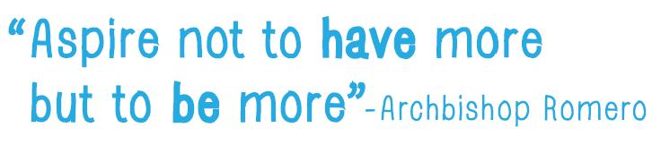

Written for OWW by
Kieran O’Brien (CAFOD)

Notes for the service leader

This outline can be developed and adapted to your own preferences and needs. There are additional resources and prayers that are also included in this pack which you may want to use. The format follows a simple structure of:
- Welcoming – rather than a formality, this should be seen as a welcoming of ourselves into sacred space
- Grounding – the context of which we are gathered in prayer
- Penitential – a time to reflect on our failings, so that we can name them in order to help us move into transformative space
- Reflection – Scripture and stories told by our sisters and brothers from the global south
- Ritual – to move out of words and readings, and into a space of ritual and connection
- Commissioning - moving into action

Additional materials
  - Stories told by our sisters and brothers from the global south (p.5-7)
  - Archbishop Oscar Romero, a guiding light, with prayers (including a Welsh version), (p.8)
  - More Prayers for this theme (p.9)

Opening Hymn or Song – WELCOMING
Hymn or song
Leader 1
We pray to the Trinity to bless us throughout this service.
With the blessing of the Father in whose image we are created,
With the blessing of the Son, who enters fully into the here and now, into all the joys and the sorrows of this world,
With the blessing of the Holy Spirit who renews and sustains us in all that we do.
We ask their blessing as we make the sign of the cross together.

All: In the name of the Father, the Son and the Holy Spirit. Amen.

Opening reflection – GROUNDING
Leader 2
“Who shall stand in his holy place? The man with clean hands and pure heart, who desires not worthless things.”- Psalm 23:3-4
Which one of us can stand in God’s holy place when we all desire worthless things? This desire seems to be part and parcel of living in a materialistic culture. We are bombarded daily with so many adverts and marketing campaigns that it seems almost impossible not to want more, to have the new and improved model, or the latest fashion. But the irony is that the more we have the more we want. Or as the recovering addicts say “We need more and more of what doesn’t work”.
Living in a materialistic culture has its dangers. Seeking happiness through material goods always locates our source of happiness externally, but true and lasting happiness is always found internally. This is why materialism can impoverish us, for it makes us live our lives out of a sense of incompleteness. It embodies within us a restless heart.
Our overconsumption also has a devastating impact on the lives of our sisters and brothers across the globe. Our consumer spending patterns enforce and maintain a global financial market that keeps whole communities and countries trapped in poverty. Also our planet is being irrevocably damaged by our overconsumption, taking for ourselves what should be left for future generations.
How do we re-address the balance, how do we find happiness within our limits, how can we strive for more than enough? “Aspire not to have more but to be more”, the famous quote of Oscar Romero is especially pertinent today, as this hints that we have placed too much emphasis on having, rather than being.
Let us move into a space where we can reflect and consider what “BEING more” rather than “HAVING more” might involve.
Let us pause for reflection

Leader 2
Penitential rite

Lord, in our relentless drive to accumulate cheaper goods and to consume more and more we have forgotten the impact that our lifestyles have on our sisters and brothers who are poor. We have supported and helped to maintain the very structures which keep them in poverty. Forgive us.

All: Kyrie Eleison (or “Lord, have mercy”)

Lord, we have fallen out of kilter with the rhythms of the earth and have lost our connection with the natural beauty that surrounds us. We have squandered the bounty which you gave us for the benefit of the rich. We have marred your image, God. Forgive us.

All: Christe Eleison (or “Christ, have mercy”)

Lord, we have failed to stand in solidarity with our sisters and brothers who suffer from oppression and injustice, failing to use our voices for the greater good. Even though we consume the goods which they produce for us, the poor still remain invisible. Forgive us.

All: Kyrie Eleison (or “Lord, have mercy”)

God of compassion, merciful God, may our prayer of repentance be a point of conversion, turning the hearts of many back to you. This we ask in the name of Jesus our brother and redeemer. Amen

Readings – REFLECTION
Reading 1 – Global story (Marta’s story is on pages 5-6 and Efrain’s is on page 7)
Reading 2 - Matthew 6:25-34
“So do not worry, saying, ‘What shall we eat?’ or ‘What shall we drink?’ or ‘What shall we wear?’
For the pagans run after all these things, and your heavenly Father knows that you need them.”

[Pause for reflection]

Letting go – RITUAL

There are two options for this ritual – the first is a drama, the second is a burning ritual.

Drama – leader invites everyone to come to the front and asks people to bring up their (imaginary) most precious material possession. Be it their mobile phone, musical instrument, book, jewellery etc. They are then placed in an (imaginary) bin. The leader then, slowly with great purpose and meaning, pretends to pour petrol on all the offerings, takes out an imaginary box of matches, strikes one, and sets it alight.

Let there be a moment of reflection after the ritual. No need to analyse, ask people to share their thoughts; rather let the group be silent for personal reflection.
The second version, same as above, but ask people to write down on a small piece of paper their most precious material possession and put it in a heat proof bowl/bin and set alight. For this version you will need to consider health and safety implications of starting a small fire indoors, with at the very least a bucket of water on hand!

Hymn or song

Be more - COMMISSIONING

Leader 1 – As we move forward from this liturgy, we called to mind the challenging words of Oscar Romero to be more. So let us say together:

We commit ourselves to celebrating and seeking happiness in what we have, rather that aspiring for more and more worldly goods.
We commit ourselves to stand in solidarity with our sisters and brothers throughout the world who are denied their basic needs, and to challenge the market forces that keep them in poverty.
We commit ourselves to treading lightly on this earth, ensuring that our patterns of consumption will protect resources for future generations to come.
We commit ourselves to finding space in our lives for silence, prayer and reflection, so that we can live simply, finding peace and happiness in what we have.
AMEN.
Blessing
May our lives be blessed with a renewed sense of peace and happiness,
and may we all learn how to take no more than enough for ourselves.
Renew in us your vision of wholeness,
that the rich may restore wealth to the poor
and the poor share blessings with the rich.
Revive in us a passion for justice,
that the tyranny of profit be quelled
and whispers of freedom find voice.
Refresh in us our sense of calling,
that we may follow Christ in serving others
and live simply with those who simply live.
AMEN.
Adapted from a prayer Annabel Shilson-Thomas/CAFOD

Hymn or song

Marta’s story

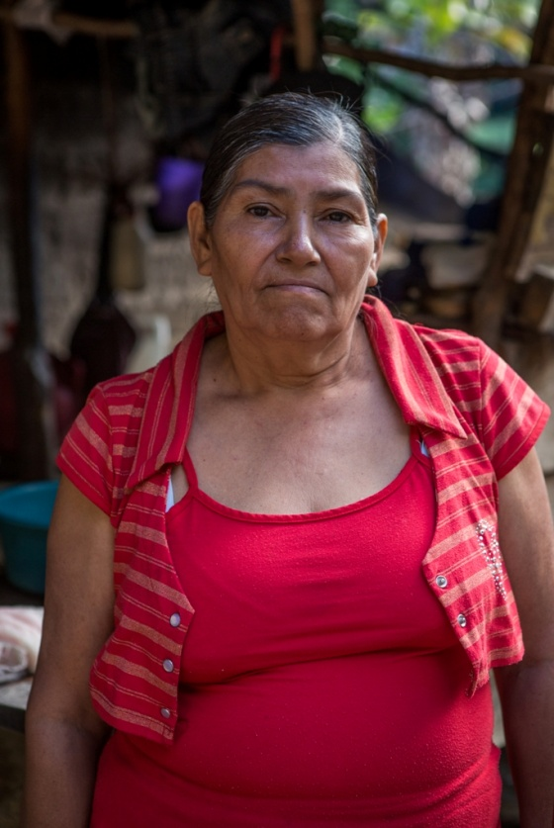
Marta, weak from the leukaemia that is killing her, speaks quietly: “There are times” she says, “when I have had to forsake my medicine because we needed food. I find it very hard to see the children suffering. Why should we live like this because we are poor?”

In this remote village in northern Nicaragua, 60-year-old Marta – a grandmother – lives in a small house with three generations of her family. It is a matter of faith for her to open her doors to those who need her help.

Marta’s granddaughter, Mayling is making tortillas. Her small, thin fists beat the balls of maize flour and water. She looks up with bright, intelligent eyes holding a finished tortilla. It is the width of a pound coin and barely covers her hand.

“When we don’t have very much” Mayling explains, “we eat two tortillas a day with salt sprinkled on them. Other times we have to go hungry. “When I am hungry, my stomach gurgles and I feel dizzy. I can’t concentrate at school.”

Marta’s husband works over the border in El Salvador. He migrated to find work as there was nothing for him in Nicaragua and he now sends back money from picking coffee in El Salvador– the household relies on this cash to stay alive.

The hunger roulette
I watch Marta chop wood. Her body shudders with each blow of the axe. It is a painful sight – her eyes wincing as the wood slowly splits. She takes a seat to rest and tells me a story about how she struggles to get food.

Like many households in the area, she is unable to grow much of her own food because of the poor soil. So, after agreeing a price, she pays a farmer in advance for part of their harvest. When the time comes, she goes to the farmer to collect the food. If the harvest is good, she collects what was agreed, if it isn’t so good or if the farmer cheats her, she collects less. The family’s chance of eating is also prey to the whims of the weather; they can never know for sure that next month they will have enough to eat.

Marta isn’t alone in having to take chances just to feed her family. According to Ligia Briones, a farming expert and founder of local women’s organisation La Asociación de Mujeres Productoras (Women Producers’ Association), one in five people in this area don’t have reliable access to the food they need. Many of these, like Marta, have to live with the daily uncertainty: ‘Will the harvest come good? Will we eat tomorrow?’

Beautiful bees
With support from CAFOD, Ligia and her colleagues have started training up families in the area as beekeepers. Women learn how to look after the bees and form groups to sell the honey, pollen, royal jelly and bees from the hives.

The honey Marta brings home is a valuable source of energy for the family, supplementing their diet – essential to help Marta live with her leukaemia. It also has antiseptic properties which help some of the ailments the family suffer from. With the surplus from the honey, Marta hopes to be able to pay for some of Mayling’s schooling. The little girl has been awarded the prize as best student in her school for two years running and dreams of becoming a teacher. But quite simply: lack of food puts her future education at risk.

Marta has worked hard all her life. Now that’s she’s a grandmother she should be able to enjoy life too. And that’s where the other benefits of bee-keeping – a sense of community, solidarity and love – come in. “Working with the women feels relaxed,” says Marta. “I love being with them. I feel happy. I love being part of a group. Being with the women helps me with my depression.”

By Mark Chamberlain / CAFOD
Photo: CAFOD/Nikola Ivanovski

Efraín’s story
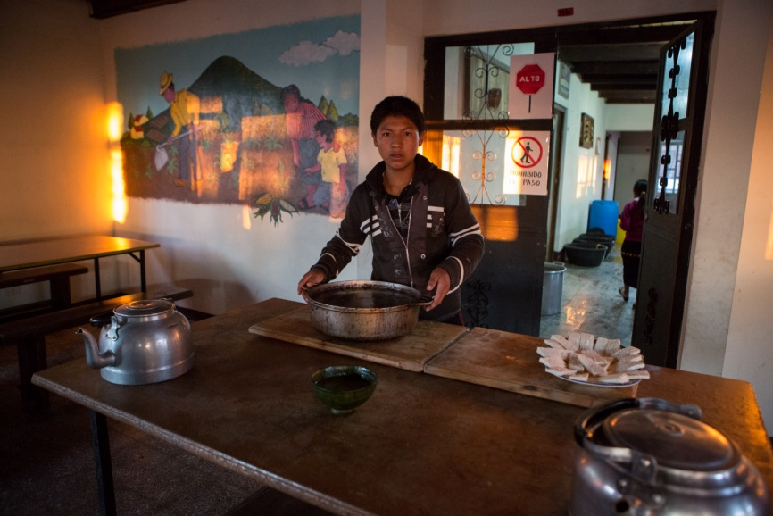
Efraín is 16. Like most Guatemalan boys his age, he loves football. He is also very popular and is the head boy at his school.

Three years ago, Efraín’s life was very different. His family fled his violent father in the middle of the night and went to live with a relative. They had no way of supporting themselves and there were days when they had to eat rotten avocados to stay alive. With little food, no money coming into the family and no home to call his own, Efraín dropped out of school to earn money for his family.

But Efraín desperately wanted to go to school. He went to the capital, Guatemala City, cleaning shoes to earn money. He sent half his wages back to his mum and kept half to support himself and save to go to school. After a year, he had enough to send himself to school.

His story is seen in households throughout Guatemala: the school enrolment rate in rural areas like Efraín’s is low – just 35 per cent. Many young people have to leave school to earn money to support their family. Being able to learn always takes a back seat if going to work means your family can have food.

The school Efraín chose is supported by CAFOD. Efraín learns how to grow vegetables, look after animals and sell crops. Whatever the young people grow at the school, they eat. So every day, Efraín sits down to a breakfast, lunch and dinner that is not only nutritious, but that he’s grown himself.

“The school is like heaven,” says Efraín. “I get to eat good food and I can learn how to grow it. I know that if I don’t get a job when I leave school, I can still support my family [by growing food].”
Photo: CAFOD/Nikola Ivanovski

Archbishop Oscar Romero: a guiding light

Oscar Romero was Archbishop of San Salvador, the capital of El Salvador in Central America. He lived at a time of terrible oppression and violence, when many people in the church were targeted because their commitment to the poor led them to speak out against injustice. After years of persecution and threats Romero was assassinated on 24 March 1980. He is remembered for his courage, his faith and, above all, his great love for the poor. ‘Many’ he said, ‘would like the poor to keep on saying it is God’s will for them to live that way. But it is not God’s will for some to have everything and others to have nothing. That cannot be of God.’
Oscar Romero’s memory is a source of strength and encouragement for millions of people throughout the world. ‘He was a guiding light for his people…as pastor, as shepherd, and as teacher.’ Jon Sobrino SJ.

Prayer
May the courage of Oscar Romero inspire us to work with integrity for an end to violence and poverty?

Goleuni sy’n arwain
Yr Archesgob Oscar Romero
Roedd Oscar Romero yn archesgob San Salvador, sef prifddinas El Salvador yng Nghanol America. Bu’n esgob yn ystod cyfnod o orthrwm a thrais dychrynllyd, pan oedd nifer o bobl a godai eu lleisiau dros y tlodion yn cael eu herlid. Wedi blynyddoedd o fod yn destun bygythiadau, lladdwyd Romero ar 24ain o Fawrth 1980.
Cofir Oscar Romero am ei ddewrder a’i ffydd, ond yn anad dim am ei gariad mawr tuag at y tlodion. ‘Fyddai llawer,’ meddai, ‘yn hoffi bod y tlodion yn dal i ddweud mai ewyllys Duw yw iddyn nhw fyw felly. Ond nid ewyllys Duw yw bod rhai’n perchen ar bopeth a rhai eraill ar ddim. Nid oddi wrth Dduw daw hynny.’
Mae coffadwriaeth Oscar Romero yn ffynhonnell nerth a chalondid i filiynau o bobl ledled y byd. ‘Fu’n oleuni i dywys ei bobl… yn offeiriad, yn fugail ac yn athro.’ Jon Sobrino, SJ

Gweddi
Bydded i ddewrder Oscar Romero ein hysbrydoli ni i weithio’n ddygn dros roi pen ar drais a thlodi.

For All Humanity
‘How many there are that would do better not to call themselves Christians, because they have no faith. They have more faith in their money and possessions than in the God who fashioned their possessions and their money.’
Archbishop Oscar Romero,Pentecost, 1979

More Prayers

God the Holy Spirit
Remove from us all desire for more money and possessions and cease our
relentless quest for comforts that we do not need.
Make us aware of how much we already have and help us to share our wealth
and time in partnership with all of humanity.
Ignite in us the fire of your love so that, filled with your Spirit, our faith is
awakened by renewed commitment and deed.
Amen.
Tony Singleton/CAFOD

Livesimply prayer
Compassionate and loving God,
you created the world
for us all to share,
a world of beauty and plenty.
Create in us a desire to live simply,
so that our lives may reflect your generosity.

Creator God,
you gave us responsibility for the earth,
a world of riches and delight.
Create in us a desire to live sustainably,
so that those who follow after us
may enjoy the fruits of your creation.

God of peace and justice,
you give us the capacity to change,
to bring about a world that mirrors your wisdom.
Create in us a desire to act in solidarity,
so that the pillars of injustice crumble
and those now crushed are set free.
Amen. Linda Jones/CAFOD

