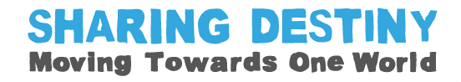
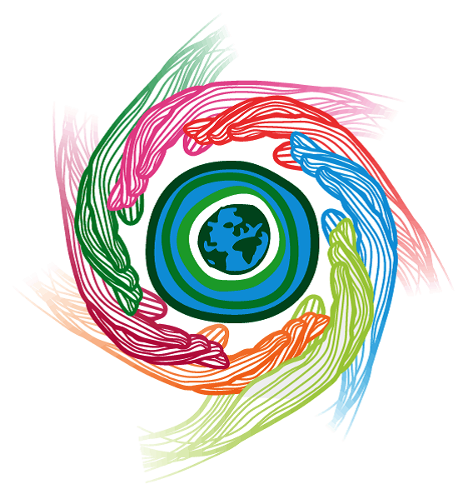
Environmental Pledges



Environmental Pledges
Introduction
What are your environmental priorities?
What kind of legacy do you want to bequeath to future generations?
The United Nations Environment Programme (UNEP) has defined ‘six priorities’:
Climate Change
- Assisting countries to adapt to climate change and to mitigate climate change.
- Reducing emissions from deforestation and forest degradation.
- Raising awareness of climate change and its effects.

Disasters and Conflicts
- Preventing and reducing the impacts of natural hazards on vulnerable communities.
- Assessing the environmental risks to human health, livelihoods and security following conflicts, disasters and industrial accidents.
- Implementing environmental recovery programmes and using environmental cooperation to transform the risks of conflict over resources into opportunities for peace in war-torn or fragile societies.

Ecosystem management
- Promoting the management of ecosystems, and explaining its advantages for development.
- Assisting national governments to find ways to restore ecosystems and biodiversity.

Environmental governance
- Prioritising the integration of ‘environmental sustainability’ as a part of regional and national development policies.

Harmful substances and hazardous waste
- Conducting assessments of the environmental consequences of harmful substances and assists governments to develop policy and control systems for harmful substances of global concern.

Resource efficiency
- Developing policy tools that accelerate the shift towards more resource-efficient societies.
- Building networks and industry partnerships that help small and large businesses adopt resource-efficient technologies, products and services.

This document will help you think about your environmental priorities. We have compiled a set of potential environmental pledges to be used at OWW events –it includes many from the theme ‘Living for One World’ but has adapted them and added to them to provide pledges suitable for ‘Sharing Destiny – moving towards one world’. In addition to the pledges themselves there is an introductory paragraph for OWW organisers and guidance on how to use the resource.

How can I use this resource?
Be aware of your power to make a difference. By taking a stand to live in greater harmony with the environment you will not only enhance your life and the lives of those around you but you will be making a positive contribution to future generations. Your actions will spread the idea of environmental justice far and wide and you will be sharing destiny .
- As a warmer, you could read the UNEP’s ‘six priorities’ for the environment, and then ask the group to discuss what they consider to be the most important of these priorities in pairs or small groups. This could be followed by whole group feedback, leading into the personal peace pledge activity.
Alternatively you could choose a selection of quotations from our compilation of ‘Sharing Destiny’ quotes to stimulate reflection and discussion
- Hold an OWW Sharing Destiny Pledge event to encourage people to Act for Change by committing to these environmental pledges! You could separate the pledges from the reasons, and ask people to match them back together. To add a competitive element, people could work in teams, with the first team to complete the task correctly winning a small prize.
- Put all of the pledges into a ‘Pledge Box’ and take it in turns to pick one out. Discuss how the pledge could be implemented.
- Put your pledge into action and make sure you regularly check how well you are doing. Encourage others to join you, and keep each other motivated.
- Display your pledges by writing them on strips of brightly coloured paper and linking them together in a ‘Environmental Pledge Chain’ that could be displayed in your office, school, place of worship or community centre.
- Create an environmental pledge cloud, with raindrops containing the pledges below it, as a decorative wall display. Alternatively, you could create a collage of colourful hand prints with the pledges written over them.
Send us your pledges with your name and locality and we will publish them on our website to inspire others.

Sharing Destiny - Environmental Pledges
You can use these pledges or write your own. Think about what is important to you, and how you can have an impact in building a world fit for our children to live in.
I pledge to…  Ride a bike instead of taking the car when making short trips... | Why?  Because you can reduce your carbon footprint and help safeguard the future for the next generation and get some great exercise, all at the same time!
I pledge to…  Find out about a religion I do not know much about... | Why?  Because we share our destiny with people of all the world’s major religions. They all advocate environmental sustainability, and provide a valuable insight into the importance of our natural environment.
I pledge to…  Support local community initiatives in my area... | Why?  Because these projects can bring people together, improve relationships and develop the community and we can only care for the future of the planet and its people if we work together .
I pledge to...  Pray for environmental sustainability at the personal, local and global levels... | Why?  Because praying can be a powerful and positive experience, and all faiths teach the importance of environmental sustainability.
I pledge to...  Remember that: “we do not inherit the earth from our ancestors; we borrow it from our children.” (Native American proverb) | Why?  Because that understanding will encourage me to do all I can to protect the earth and for future generations.
I pledge to...  Create a place of peace and tranquillity, a garden for myself and others to use... | Why?  Because it is good to have somewhere quiet to retreat to when life is too hectic. Opening this space up to others will give them the opportunity to find inner peace, appreciation of the planet and its people and to think about how it will be for future generations .
I pledge to…  Turn the tap off when I clean my teeth... | Why?  Many people don’t have access to fresh water, and what the world does have is running out. Some experts think that we will soon be fighting ‘water wars’ because of this shortage, so we shouldn’t waste what we have.
I pledge to…  Keep buying Fairtrade products... | Why?  Because buying fairly traded products means a better deal for the producers, which not only allows them to feed and educate their families, access healthcare, develop their communities but also to care for their land and adapt to climate change.
I pledge to…  Tell my local MP what I would like her/him to do to ensure environmental sustainability in my community... | Why?  Because if enough people speak up, change will really happen.
I pledge to…  Turn my television off at the set, and not use the remote to leave it on stand-by... | Why?  Because all that wasted energy is damaging to the environment.
I pledge to…  Go through my cupboards and check that I am using biodegradable products to wash and package everything... | Why?  Because they break down so much quicker than their equivalents and so damage the environment less.
I pledge to…  Write on both sides of every piece of paper... | Why?  Because it produces less waste so it is kinder to the environment. Deforestation ruins indigenous homesteads and animals’ habitats, creating social and environmental instability and threatens to leave future generations without species we enjoy today.
I pledge to…  Eat less meat... | Why?  Because if we ate less meat we could afford free-range meat which enables livestock to live in a more natural environment; - and would reduce greenhouse gas emissions and safeguard our health too. (Animals living indoors close together need lots of antibiotics to stay healthy ; that encourages antibiotic resistance which can be passed on in their meat, threatening the human health)
I pledge to…  Buy organic goods whenever possible... | Why?  Because other crops are sprayed by highly pollutant insecticides which not only damage the environment but the communities around the farming areas. Health, economic and environmental sustainability are key aspects in ensuring lasting peace.
I pledge to…  Eat local fruit and vegetables when in season (not forced in glass houses) and continue to eat Fairtrade imports too... | Why?  Because local produce uses less energy than goods imported by air. Most imported Fairtrade produce comes by boat – so it uses less CO2 energy in the production costs than local glass house crops. Supporting your local farmers will reduce food transport costs, while buying Fairtrade will give poor farmers in developing countries a secure economic base from which to adapt to climate change and care for their families and their environment.
I pledge to…  Buy wood with the FSC logo on it... | Why?  Because wood consumption is so high that many forests are being illegally logged. This symbol verifies that your wood is from a sustainable source.
I pledge to…  Take action against environmental injustice... | Why?  Tell your MP how you feel! Writing a letter is powerful tool on the side of right.
I pledge to…  Take a shower rather than a bath... | Why?  Because it saves 50 litres of water to take a shower instead of a bath. The UK has less available water per person than most other European countries. The amount of CO2 produced in a year by an average family’s water consumption is the same as a return flight from London to New York. Therefore, saving water will help alleviate climate change and can make the water scarcity problem in another country less severe. It will also save you money on your water and energy bills.
I pledge to…  Tell a friend about fair trade... | Why?  Because the more people who buy fair trade the bigger impact we will have on gaining trade justice and changing the lives of producers around the world, enabling them to support their families, care for their environment and adapt to climate change.
I pledge to…  Start a direct debit to an agency that works alongside the world’s poorest people... | Why?  Because when charities have a regular income rather than occasional gifts, they can plan better and use the money in more efficient ways to work towards environmental justice through various initiatives.
I pledge to…  Make compost... | Why?  Because although 60% of household rubbish could be composted, 80% of it is ending up in the local landfill site. As these sites fill up new land must be found to dump waste, which damages the local community and the global environment.
I pledge to…  Find out about and use toy libraries... | Why?  Because you save money, get to know new people, and limit the consumer demand for ‘throw away’ plastic toys.
I pledge to…  Re-use and then recycle everything I can and use recycled goods whenever possible... | Why?  Because it creates less waste, so you are helping the environment.
I pledge to…  Give life-changing presents... | Why?  Because billions of pounds are wasted every year on unwanted gifts. But through Oxfam or Christian Aid (among others) you can buy packages that deliver a beautiful card to your friend and chickens, medical equipment or a goat to a family in the developing world. We can only care for the planet if we care for its people too.
I pledge to…  Re-use my plastic carrier bags, or buy a ‘bag for life’... | Why?  Because it will help to limit the amount of plastic bags that end up in landfill sites, killing helpless birds and animals.
I pledge to…  Reduce my speed and stick to the speed limit... | Why?  Because slower driving will cause less accidents and will lower your CO2 emissions. You will help to ensure safety in every community you drive through and help to limit climate change.
I pledge to…  Turn down the central heating thermostat by one degree... | Why?  Because by putting on a cosy jumper instead you are helping to limit global warming and the damage that it does across the world.
I pledge to…  Support organisations like the Royal Society for Protection of Birds which has projects to protect the habitats of endangered species. | Why?  Because I want our shared destiny to include tigers and biodiversity for future generations to enjoy.
I pledge to…  Read and share good news stories!... | Why?  Because they will put the bad news into perspective, demonstrate that others are taking action and they can join them. They will inspire people to believe that a better world is possible.

You might also find our compilation of Sharing Destiny quotes a useful resource

